**Group Section**

1. Identify the personas/imagined users for the products ([Sommervile pg. 55 (Links to an external site.)](https://www.amazon.com/Engineering-Software-Products-Ian-Sommerville/dp/013521064X/ref=sr_1_4?crid=2P6J7EKB9SHO7&dchild=1&keywords=software+engineering+sommerville&qid=1590377760&sprefix=software+engineering+som%2Caps%2C176&sr=8-4)).
   1. Persona 1: Bill Shafer
      1. Age:35-55
      2. Occupation: Policy Maker
      3. Goal: To ensure that World Bank funds are allocated properly to ensure a bright future for the next generation
      4. Frustrations: There's currently no way for him to see which countries that receive aid from the World bank have high child mortality rates without taking up too much of his time.
   2. Persona 2: Mandy Bright
      1. Age: 18-30
      2. Occupation: College Student
      3. Goal: She must write a paper on international aid and how its disbursed
      4. Frustrations: It's easy for her to find what countries receive aid from the world bank but it’s hard for her to tell the overall health of these counties economically and the health of their citizens.
   3. Persona 3: Syrus Till
      1. Age: 65+
      2. Occupation: Retired
      3. Goal: He is interested in world politics and wants to know how certain countries are doing.
      4. Frustrations: Since he is retired he has all the time in the world to look up information on the topic but given his age, some websites are difficult for him to navigate and find the information that he needs.
2. Identify other stakeholders of the projects (People other than direct users who you could require data or input from or who may indirectly benefit from the product).
   1. The world bank
   2. UNICEF
   3. Everyone who provides or collects data for the two above
3. Each member of the group should act as an expert for the "Ask the expert section"

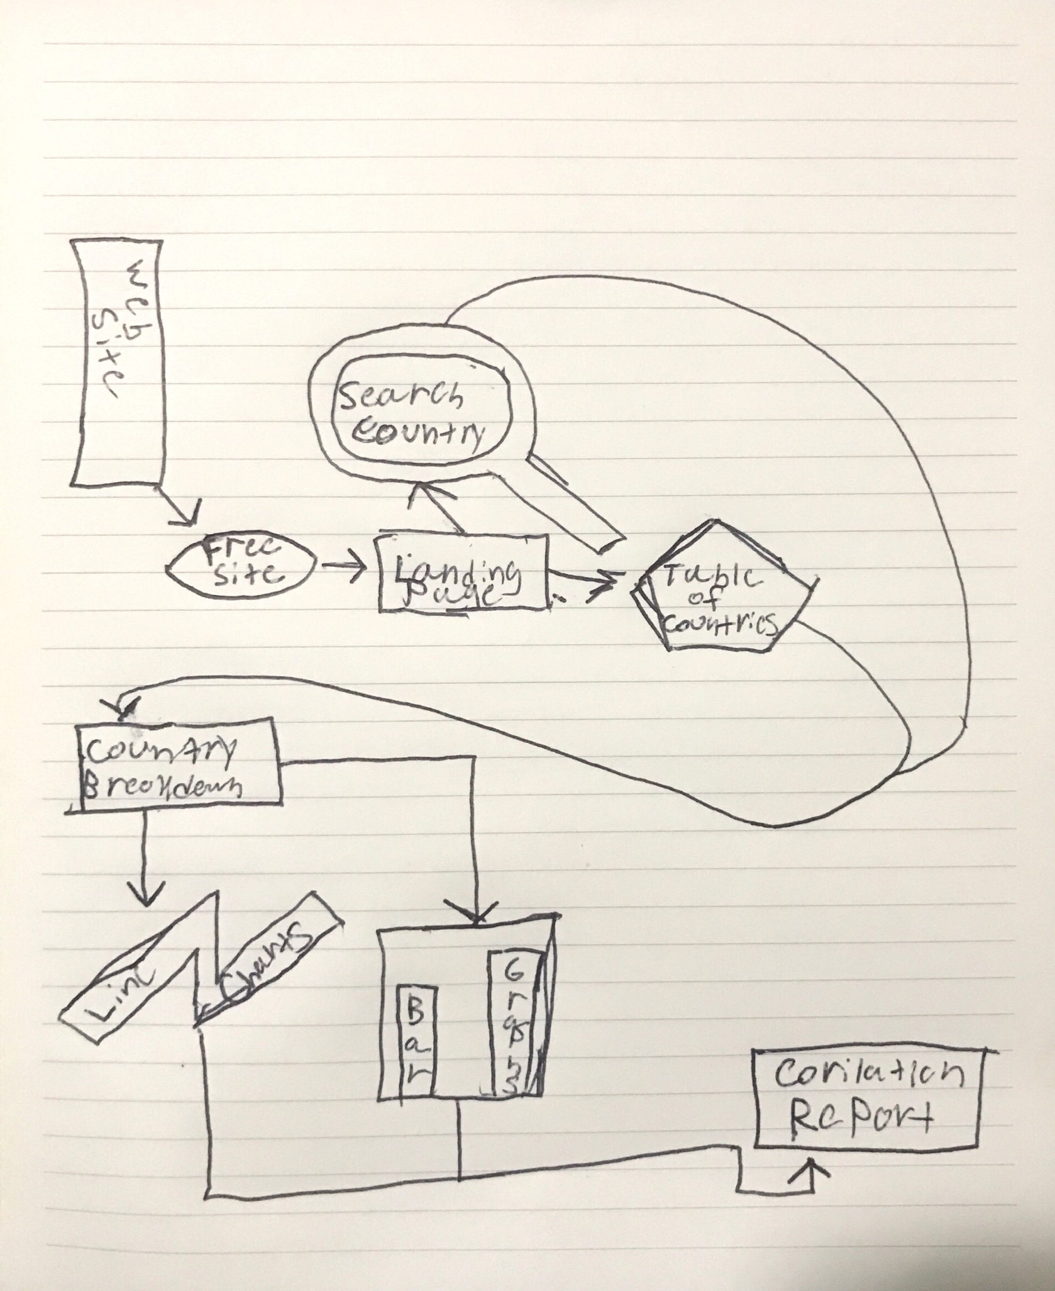**Individual Section**

1. Map
2. User Stories
   1. As a policy maker I want to compare how World Bank aid is distributed
   2. As a college student I want a reliable source to gather information about my upcoming paper
   3. As a retired individual I want a easy and user friendly platform to do personal research
3. Feature list
   1. A compare feature to look at multiple countries at once
   2. A page dedicated to our data sources and how the process of analyzing it.
   3. A help button to guide users when they get stuck or feel
   4. A way to display the data in either a bar, line or circle chart
   5. Analytic tools to show different scenarios or time frames